OOPS LAB

Experiment -10

NAME- ANMOL YADAV SAP ID- 500083814 ROLLNO- R214220178

**Question: 1**

Create a database table to store the records of employee in a company. Use get Connection function to connect the database. The statement object uses execute Update function to create a table.

**Code:**

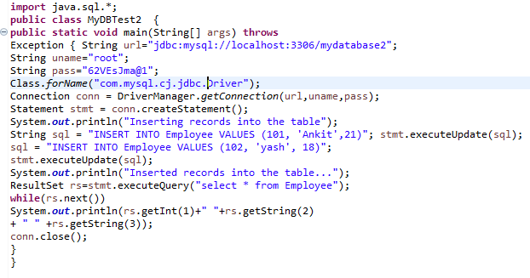

**Output:**

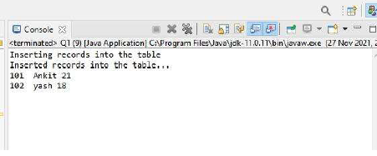

**Question: 2**

Create a database of employee of company in mysql and then use java program to access the database for inserting information of employees in database. The SQL statement can be used to view the details of the data of employees in the database.

**Code:**

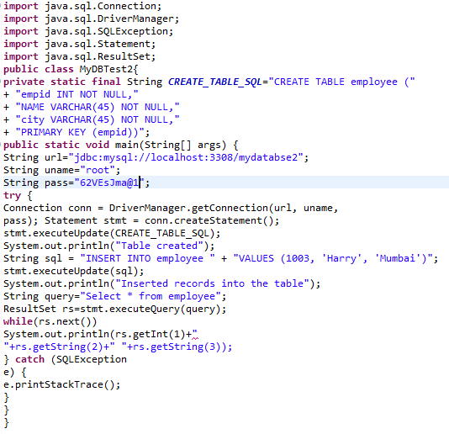

**Output:-**

